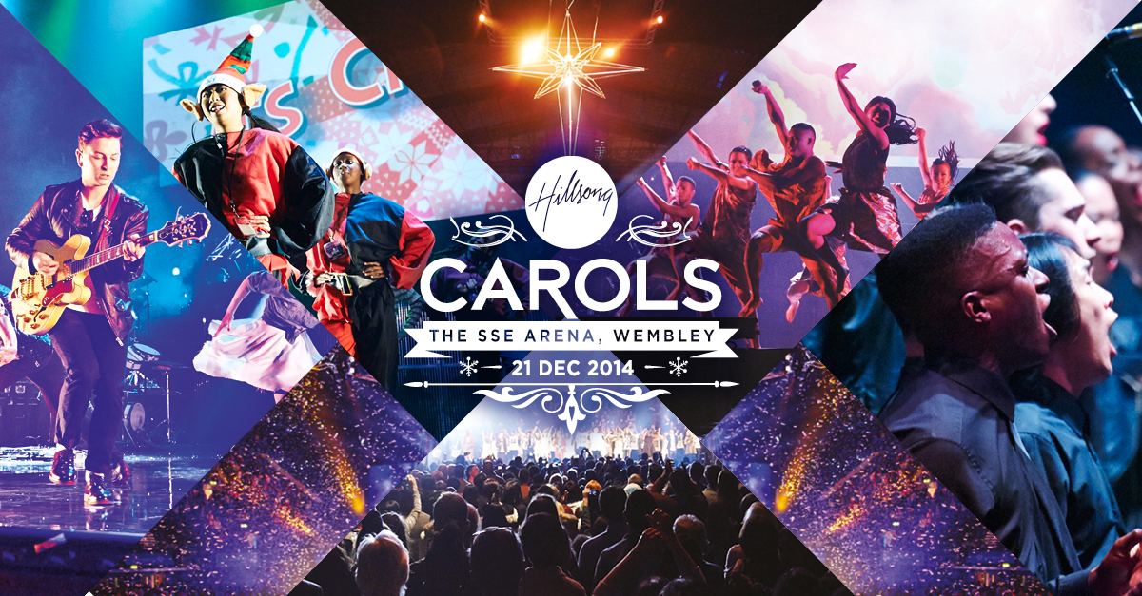

JOIN THE BIGGEST FESTIVE SPECTACULAR OF THE YEAR!

On Sunday 21st December 2014, for the third year running, the biggest carol service in London will take place at The SSE Arena (formerly Wembley Arena). Over 10,000 people are anticipated to attend this multimedia extravaganza with 50% of tickets already sold.

The Hillsong Christmas Carol Service will be a show-stopping performance with live music, dance, a medley of new and traditional carol sing-along and a few surprises that will entertain family and friends.

Watch the trailer here: https://vimeo.com/112488027

Tickets are on sale for only £5 each at www.hil.so/carols.

Hillsong London is a Pentecostal church and is the London congregation of Hillsong Church.

For backstage enquiries, press entry, exclusive interviews and images please contact: Jordan Collyer at Collider / Jordan@wearecollider.com / 07979 344 024

